 | 12.1.24 Editors - Geometry Nodes Editor - Header - Add Menu - Grease Pencil - Read
Table of content
Detailed table of content 1
Add menu - Grease Pencil - Read 1
Named Layer Selection 1

Detailed table of content
Detailed table of content
Detailed table of content 1
Add menu - Grease Pencil - Read 1
Named Layer Selection 1
Inputs 1
Name 1
Outputs 2
Selection 2

Add menu - Grease Pencil - Read
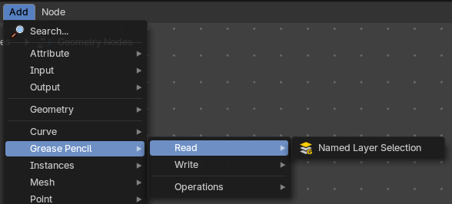
Grease pencil nodes.

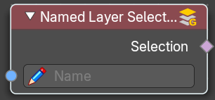
Named Layer Selection
Outputs a selection of a grease pencil layer by its name.

Inputs

Name
The name of the selection.

Outputs

Selection
The selected grease pencil geometry.

